

SESSION 2022-23

CN

(Computer Networks)

Lab File

**COURSE:- BCA**

**ROLL NO :- 41221139**

**SUBMITTED BY :- SUBMITTED TO:-**

**Sachin Rajbhar Ms. Bushra Jamal**

**Index**

|  |  |  |  |
| --- | --- | --- | --- |
| *S.No* | *Title* | *Date* | *Sign* |
| 1 | Study of following Network Devices in Detail   Repeater   Hub   Switch   Bridge   Router   Gate Way   NIC card   Firewall |  |  |
| 2 | Study of different types of Network cables and Practically  implement the cross-wired cable and straight through cable  using clamping tool. (Components: RJ-45 connector, Clamping  Tool, Twisted pair Cable) |  |  |
| 3 | Connect the computers in Local Area Network |  |  |
| 4 | Installation and Introduction to Packet Tracer   Use of various components in Packet Tracer   IP Configuration of devices in PT   Ping machines via command mode(cmd) in PT   Ping machines via simple PDU in PT   Router configuration |  |  |
| 5 | Design and Implement following topologies in packet tracer   Bus topology   Ring topology   Mesh topology   Tree topology |  |  |
| 6 | Implement following topologies in packet tracer and also  show the simulation mode along with proper labelling and  use of colour schemes to distinguish networks   Star topology  o using switch  o using hub   Hybrid topology |  |  |
| 7 | Design the connectivity between 2 PC&#39;s in Cisco packet tracer  when -   they are on same network (via ping and/or message  sending)   they are on different network via ping and/or message  sending (enable Router configuration) |  |  |
| 8 | Implementation of Data Link Framing method - Character  Count (code in Python) |  |  |
| 9 | Implementation of Data link framing method - Bit stuffing and  Destuffing(code in Python/C) |  |  |
| 10 | Study of network IP Addressing and Subnetting concepts |  |  |
| 11 | Study and Implementation of Firewall |  |  |
| 12 | To monitor network traffic using Wire Shark |  |  |
| 13 | Implement error detection method-Even and Odd Parity in Python. |  |  |
| 14 | Static and Dynamic Routing |  |  |

**PRACTICAL 1**

**AIM**: **Study of following Network Devices in Detail**

* **Repeater**
* **Hub**
* **Switch**
* **Bridge**
* **Router**
* **Gate Way**
* **NIC card**
* **Firewall**

**Repeater:**

A repeater is a dynamic network device used to reproduce the signals when they transmit over a greater distance so that the signal’s strength remains equal. It can be used to create an Ethernet network. A repeater that occurs as the first layer of the OSI layer is the physical layer.

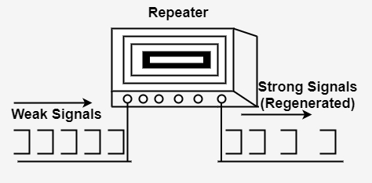

**Features of Repeaters**

* These repeaters are linked to each other at the physical layer.
* It sends the signals for the unsteady areas to enlarge the system signals.
* These receptors linked the various network signals to convert the data between the two devices.
* These receptors can support 100 % digital communication so that they do not require to wait for analog voice calls.

**Hub:**

Hubs are networking devices operating at a physical layer of the OSI model that are used to connect multiple devices in a network. They are generally used to connect computers in a LAN.

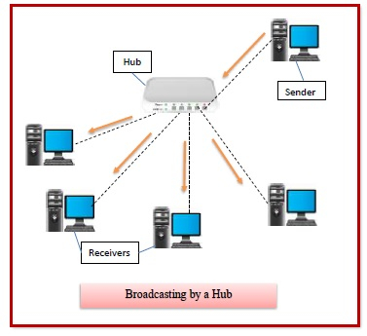A hub has many ports in it. A computer which intends to be connected to the network is plugged in to one of these ports. When a data frame arrives at a port, it is broadcast to every other port, without considering whether it is destined for a particular destination device or not.

**Features of Hubs**

* A hub operates in the physical layer of the OSI model.
* A hub cannot filter data. It is a non-intelligent network device that sends message to all ports.
* It primarily broadcasts messages. So, the collision domain of all nodes connected through the hub stays one.
* Transmission mode is half duplex.
* Collisions may occurs during setup of transmission when more than one computers place data simultaneously in the corresponding ports.
* Since they lack intelligence to compute best path for transmission of data packets, inefficiencies and wastage occur.
* They are passive devices, they don’t have any software associated with it.
* They generally have fewer ports of 4/12.

**Switch**

Switches are networking devices operating at layer 2 or a data link layer of the OSI model. They connect devices in a network and use packet switching to send, receive or forward data packets or data frames over the network.

A switch has many ports, to which computers are plugged in. When a data frame arrives at any port of a network switch, it examines the destination address, performs necessary checks and sends the frame to the corresponding device(s).It supports unicast, multicast as well as broadcast communications**.**

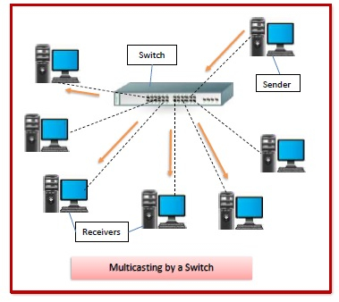

**Features of Switches**

* A switch operates in the layer 2, i.e. data link layer of the OSI model.
* It is an intelligent network device that can be conceived as a multiport network bridge.
* It uses MAC addresses (addresses of medium access control sublayer) to send data packets to selected destination ports.
* It is supports unicast (one-to-one), multicast (one-to-many) and broadcast (one-to-all) communications.
* Transmission mode is full duplex, i.e. communication in the channel occurs in both the directions at the same time. Due to this, collisions do not occur.
* The number of ports is higher – 24/48.

**Bridge**

Bridges are used to connect two subnetworks that use interchangeable protocols. It combines two LANs to form an extended LAN. The main difference between the bridge and repeater is that the bridge has a penetrating efficiency.

A bridge accepts all the packets and amplifies all of them to the other side. The bridges are intelligent devices that allow the passing of only selective packets from them. A bridge only passes those packets addressed from a node in one network to another node in the other network.

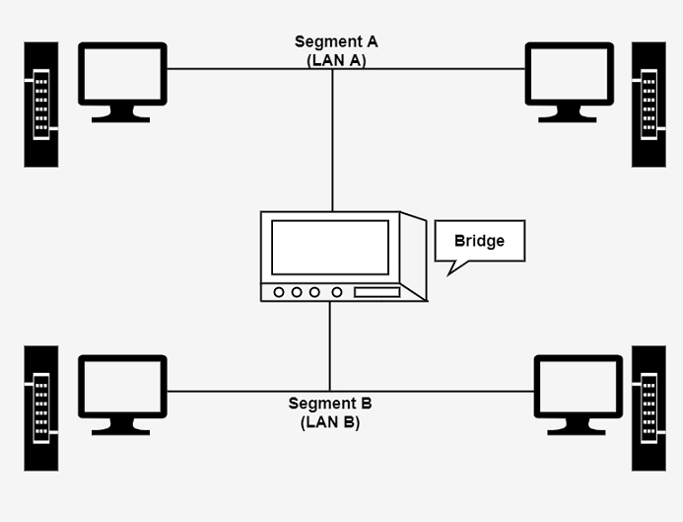

A bridge performs in the following aspect −

* A bridge receives all the packets or frame from both LAN (segment) A and B.
* A bridge builds a table of addresses from which it can identify that the packets are sent from which LAN (or segment) to which LAN.
* The bridge reads the send and discards all packets from LAN A sent to a computer on LAN A and that packets from LAN A send to a computer on LAN B are retransmitted to LAN B.
* The packets from LAN B are considered in the same method.

**Routers**

Routers are networking devices operating at layer 3 or a network layer of the OSI model. They are responsible for receiving, analysing, and forwarding data packets among the connected computer networks. When a data packet arrives, the router inspects the destination address, consults its routing tables to decide the optimal route and then transfers the packet along this route.

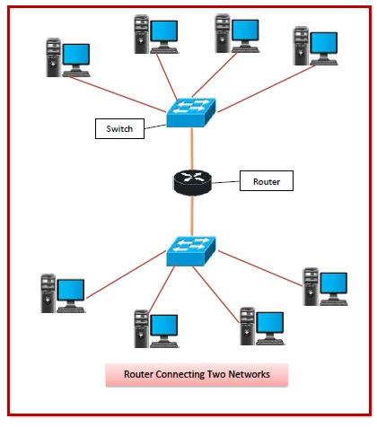

**Features of Routers**

* A router is a layer 3 or network layer device.
* It connects different networks together and sends data packets from one network to another.
* A router can be used both in LANs (Local Area Networks) and WANs (Wide Area Networks).
* In order to prepare or refresh the routing table, routers share information among each other.
* Routers provide protection against broadcast storms.
* Routers are more expensive than other networking devices like hubs,bridges and switches.

**Gateway**

A gateway is a network node that forms a passage between two networks operating with different transmission protocols. The most common type of gateways, the network gateway operates at layer 3, i.e. network layer of the OSI (open systems interconnection) model. However, depending upon the functionality, a gateway can operate at any of the seven layers of OSI model. It acts as the entry – exit point for a network since all traffic that flows across the networks should pass through the gateway. Only the internal traffic between the nodes of a LAN does not pass through the gateway.

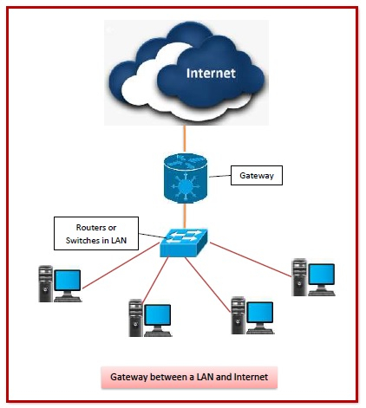

**Features of Gateways**

* Gateway is located at the boundary of a network and manages all data that inflows or outflows from that network.
* It forms a passage between two different networks operating with different transmission protocols.
* A gateway operates as a protocol converter, providing compatibility between the different protocols used in the two different networks.
* A gateway is generally implemented as a node with multiple NICs (network interface cards) connected to different networks. However, it can also be configured using software.
* It uses packet switching technique to transmit data across the networks.

**Network Interface Card**

A network interface card (NIC) is a hardware component without which a computer cannot be connected over a network. It is a circuit board installed in a computer that provides a dedicated network connection to the computer. It is also called network interface controller, network adapter or LAN adapter.

**Features**

* NIC allows both wired and wireless communications.
* NIC allows communications between computers connected via local area network (LAN) as well as communications over large-scale network through Internet Protocol (IP).
* NIC is both a physical layer and a data link layer device, i.e. it provides the necessary hardware circuitry so that the physical layer processes and some data link layer processes can run on it.

**Types of NIC’S**

1. **Internal Network Cards**

In internal networks cards, motherboard has a slot for the network card where it can be inserted. It requires network cables to provide network access. Internal network cards are of two types. The first type uses Peripheral Component Interconnect (PCI) connection, while the second type uses Industry Standard Architecture (ISA).

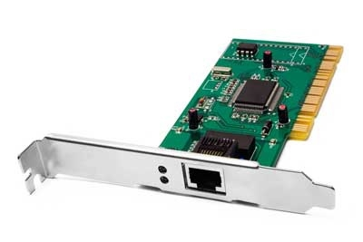

1. **External Network Cards**

In desktops and laptops that do not have an internal NIC, external NICs are used. External network cards are of two types: Wireless and USB based. Wireless network card needs to be inserted into the motherboard, however no network cable is required to connect to the network. They are useful while traveling or accessing a wireless signal.

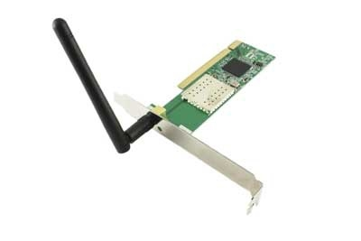

**Firewall**

A firewall is a network security device; it is a protective layer for the server that monitors and filters all the incoming and outgoing network traffic. It uses a set of rules to determine whether to allow or block a specific network traffic. Firewalls can prevent unauthorized use before reaching the servers. Firewalls can be hardware or software-based.

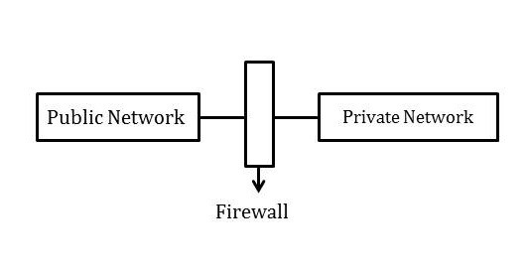

**Firewall Policies**

To protect private networks and individual machines, a firewall can be employed to filter incoming or outgoing traffic based on a predefined set of rules known as firewall policies.

Packet flowing through a firewall can have one of the following three outcomes −

* Accepted − Permitted through the firewall.
* Dropped − Not allowed through with no indication of failure
* Rejected − Not allowed through accompanied by an attempt to inform the source that the packet was rejected.

Properties of the packets and the protocols are −

* TCP or UDP
* The source and destination IP address
* The source and destination ports
* The application-level payload of the packet

**PRACTICAL 2**

**AIM**: **Study of different types of Network cables and Practically implement the cross-wired cable and straight through cable using clamping tool. (Components: RJ-45 connector, Clamping Tool, Twisted pair Cable).**

* **Twisted Pair Cable:**

It consists of 2 separately insulated conductor wires wound about each other. Generally, several such pairs are bundled together in a protective sheath. They are the most widely used Transmission Media. Twisted Pair is of two types:

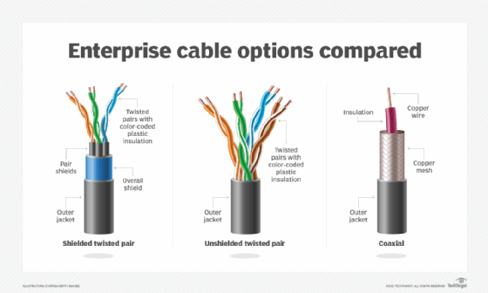

* **Unshielded Twisted Pair (UTP):**

UTP consists of two insulated copper wires twisted around one another. This type of cable has the ability to block interference and does not depend on a physical shield for this purpose. It is used for telephonic applications.

**Advantages:**

⇢ Least expensive

⇢ Easy to install

⇢ High-speed capacity

**Disadvantages:**

⇢ Susceptible to external interference

⇢ Lower capacity and performance in comparison to STP

* **Shielded Twisted Pair (STP):**

This type of cable consists of a special jacket (a copper braid covering or a foil shield) to block external interference. It is used in fast-data-rate Ethernet and in voice and data channels of telephone lines.

**Advantages:**

⇢ Better performance at a higher data rate in comparison to UTP

⇢ Eliminates crosstalk

⇢ Comparatively faster

**Disadvantages:**

⇢ Comparatively difficult to install and manufacture

⇢ More expensive

⇢ Bulky

**Applications:**

Used in telephone connections and LAN networks.

* **Coaxial cable:**

It has an outer plastic covering containing an insulation layer made of PVC or Teflon and 2 parallel conductors each having a separate insulated protection cover. The coaxial cable transmits information in two modes: Baseband mode(dedicated cable bandwidth) and Broadband mode(cable bandwidth is split into separate ranges). Cable TVs and analog television networks widely use Coaxial cables.

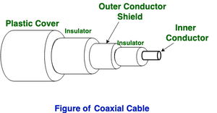

**Advantages:**

* High Bandwidth
* Better noise Immunity
* Easy to install and expand
* Inexpensive

**Disadvantages:**

* Single cable failure can disrupt the entire network

**Applications:**

Radio frequency signals are sent over coaxial wire. It can be used for cable television signal distribution, digital audio (S/PDIF), computer network connections (like Ethernet), and feedlines that connect radio transmitters and receivers to their antennas.

* **Optical Fiber Cable:**

It uses the concept of refraction of light through a core made up of glass or plastic. The core is surrounded by a less dense glass or plastic covering called the cladding. It is used for the transmission of large volumes of data.

The cable can be unidirectional or bidirectional. The WDM (Wavelength Division Multiplexer) supports two modes, namely unidirectional and bidirectional mode.

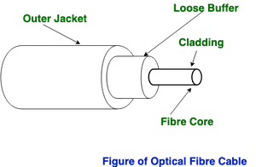

**Advantages:**

* Increased capacity and bandwidth
* Lightweight
* Less signal attenuation
* Immunity to electromagnetic interference
* Resistance to corrosive materials

**Disadvantages:**

* Difficult to install and maintain
* High cost
* Fragile

**Applications:**

Radio frequency signals are sent over coaxial wire. It can be used for cable television signal distribution, digital audio (S/PDIF), computer network connections (like Ethernet), and feedlines that connect radio transmitters and receivers to their antennas.

**PRACTICAL 3**

**AIM**: **Connect the computers in Local Area Network.**

**PROCEDURE:**

**On the host computer**, follow these steps to share the Internet connection:

1. Log on to the host computer as Administrator or as Owner.

2. Click Start, and then click Control Panel.

3. Click Network and Internet Connections.

4. Click Network Connections.

5. Right-click the connection that you use to connect to the Internet. For example, if you connect to the Internet by using a modem, right-click the connection that you want under Dial-up / other network available.

6. Click Properties.

7. Click the Advanced tab.

8. Under Internet Connection Sharing, select the Allow other network users to connect through this computer's Internet connection check box.

9. If you are sharing a dial-up Internet connection, select the Establish a dial-up connection whenever a computer on my network attempts to access the Internet check box if you want to permit your computer to automatically connect to the Internet.

10. Click OK. You receive the following message: When Internet Connection Sharing is enabled, your LAN adapter will be set to use IP address 192.168.0.1. Your computer may lose connectivity with other computers on your network. If these other computers have static IP addresses, it is a good idea to set them to obtain their IP addresses automatically. Are you sure you want to enable Internet Connection Sharing?

11. Click Yes. The connection to the Internet is shared to other computers on the local area network (LAN).

The network adapter that is connected to the LAN is configured with a static IP address of 192.168.0.1 and a subnet mask of 255.255.255.0

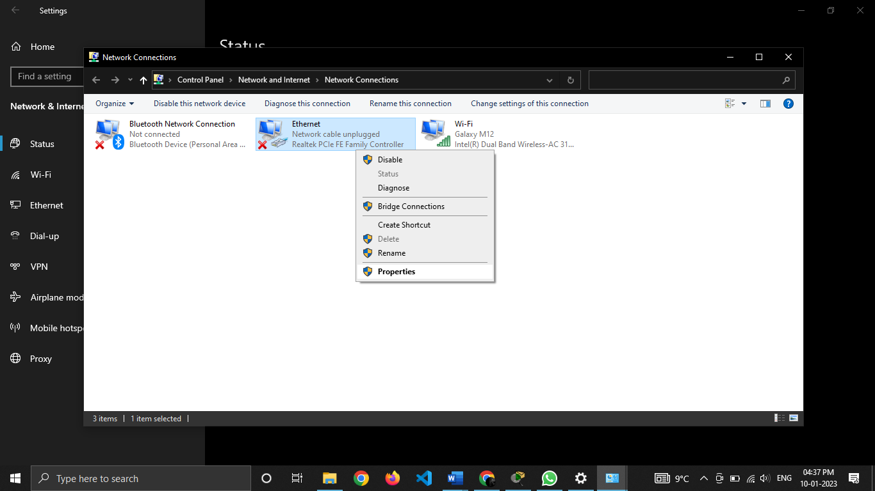 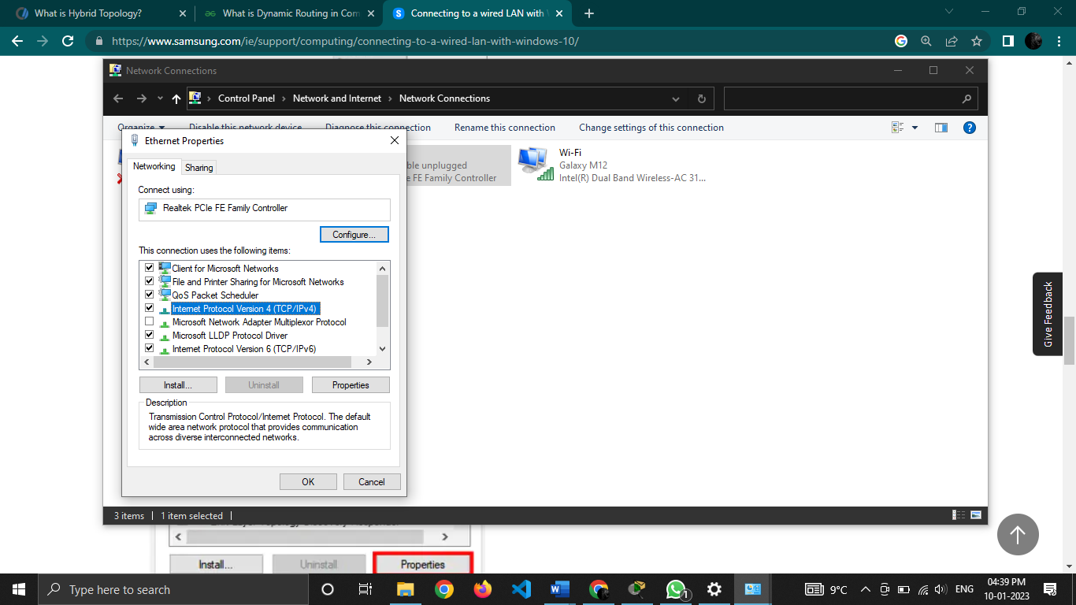

**On the client computer** To connect to the Internet by using the shared connection, you must confirm the LAN adapter IP configuration, and then configure the client computer. To confirm the LAN adapter IP configuration, follow these steps:

1. Log on to the client computer as Administrator or as Owner.

2. Click Start, and then click Control Panel.

3. Click Network and Internet Connections.

4. Click Network Connections.

5. Right-click Local Area Connection and then click Properties.

6. Click the General tab, click Internet Protocol (TCP/IP) in the connection uses the following items list, and then click Properties.

7. In the Internet Protocol (TCP/IP) Properties dialog box, click Obtain an IP address automatically (if it is not already selected), and then click OK. Note: You can also assign a unique static IP address in the range of 192.168.0.2 to 192.168.0.254. For example, you can assign the following static IP address, subnet mask, and default gateway:

8. IP Address 192.168.31.202

9. Subnet mask 255.255.255.0

10. Default gateway 192.168.31.1

11. In the Local Area Connection Properties dialog box, click OK.

12. Quit Control Panel.

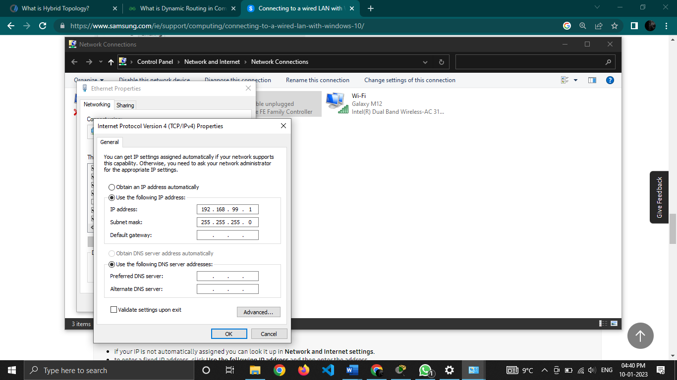

**PRACTICAL 4**

**AIM**:  **Installation and Introduction to Packet Tracer**

**DIAGRAM:**

Packet Tracer is computer software that is designed with the purpose of making network simulations to understand the networking and cyber security concepts in an easy way. It is built by Cisco Corporation and is available for free for different operating systems like macOS, Windows, Linux, etc.

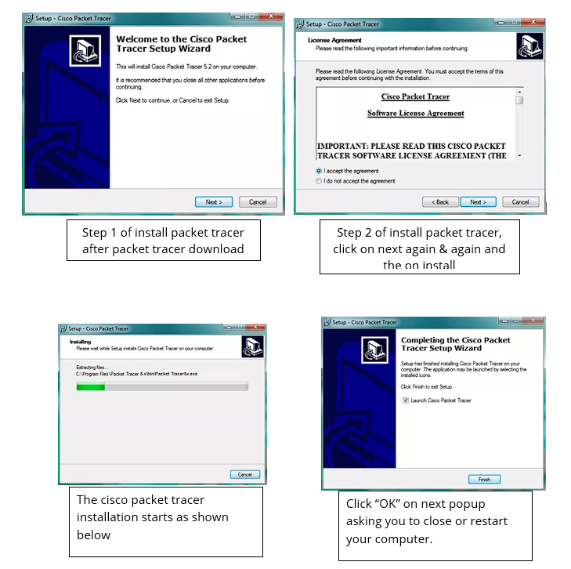

All commands related to Network configuration which includes how to switch to privilege mode and normal mode and how to configure router interface and how to save this configuration to flash memory or permanent memory.

* Use of various components in Packet Tracer

1. Area 1: Menu bar – This is a common menu found in all software applications; it is used to open, save, print, change preferences, and so on.
2. Area 2: Main toolbar – This bar provides shortcut icons to menu options that are commonly accessed, such as open, save, zoom, undo, and redo, and on the right-hand side is an icon for entering network information for the current network.
3. Area 3: Logical/Physical workspace tabs – These tabs allow you to toggle between the Logical and Physical work areas.
4. Area 4: Workspace – This is the area where topologies are created and simulations are displayed.
5. Area 5: Common tools bar – This toolbar provides controls for manipulating topologies, such as select, move layout, place note, delete, inspect, resize shape, and add simple/complex PDU.
6. Area 6: Realtime/Simulation tabs – These tabs are used to toggle between the real and simulation modes. Buttons are also provided to control the time, and to capture the packets.
7. Area 7: Network component box – This component contains all of the network and end devices available with Packet Tracer, and is further divided into two areas:
8. Area 7a: Device-type selection box – This area contains device categories
9. Area 7b: Device-specific selection box – When a device category is selected, this selection box displays the different device models within that category
10. Area 8: User-created packet box – Users can create highly-customized packets to test their topology from this area, and the results are displayed as a list.

* IP Configuration of devices in PT

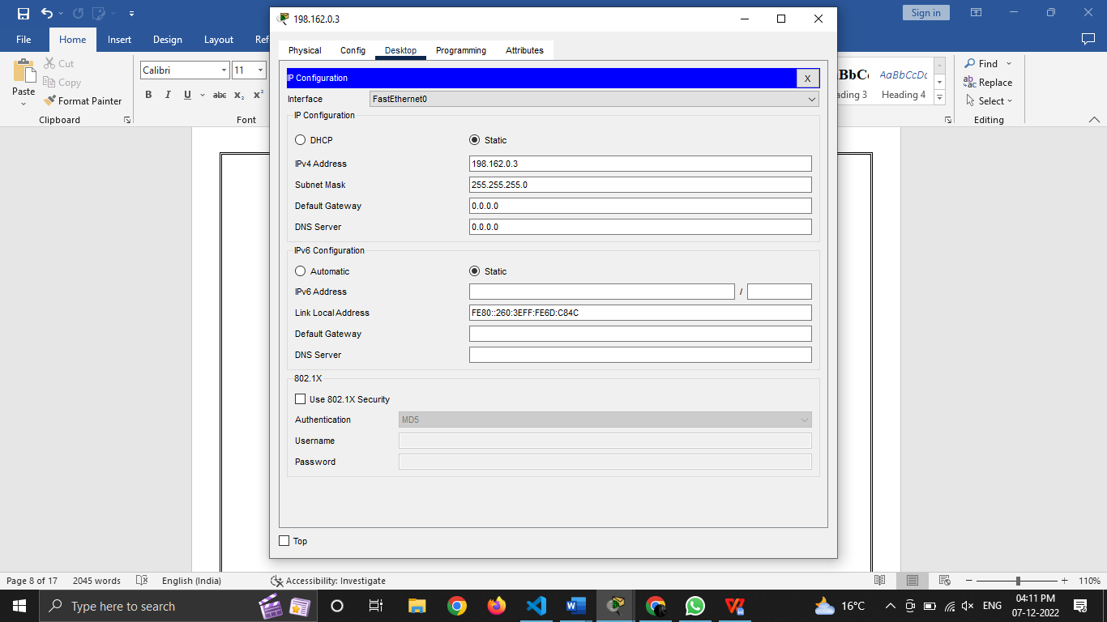

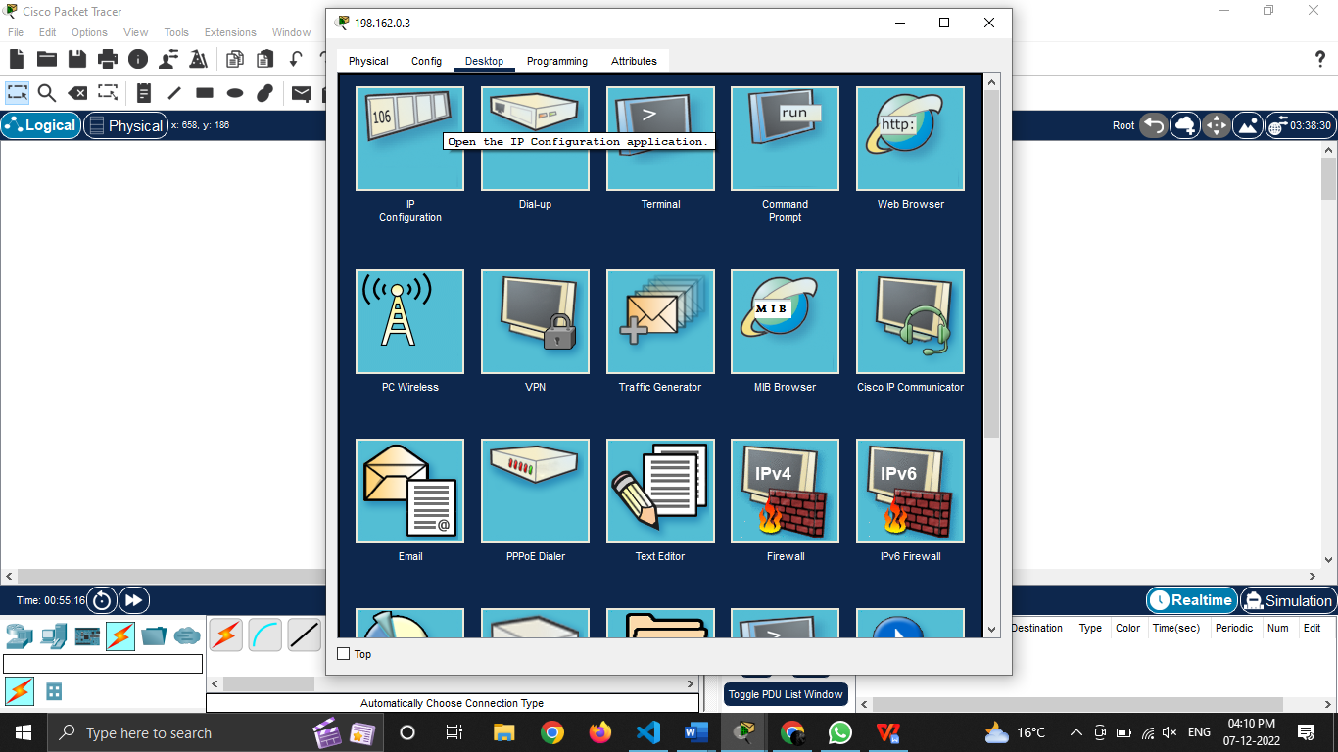

* Ping machines via command mode(cmd) in PT

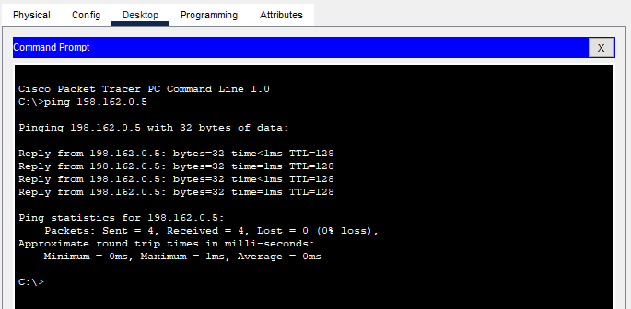

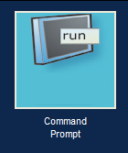

**PRACTICAL 5**

**AIM**: **Design and Implement following topologies in packet tracer**

* **Bus topology**
* **Ring topology**
* **Mesh topology**
* **Tree topology**

**Bus Topology**

Bus topology is a network type in which every computer and network device is connected to a single cable. It is bi-directional. It is a multi-point connection and a non-robust topology because if the backbone fails the topology crashes. In Bus Topology, various MAC (Media Access Control) protocols are followed by LAN ethernet connections like TDMA, Pure Aloha, CDMA, Slotted Aloha, etc.

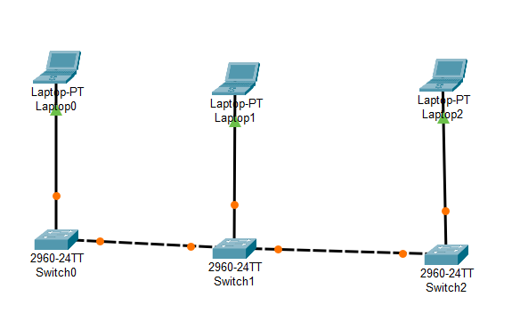

**Ring Topology**

Ring topology is a kind of arrangement of the network in which every device is linked with two other devices. This makes a circular ring of interconnected devices which gives it its name. Data is usually transmitted in one direction along the ring, known as a unidirectional ring. The data is delivered from one device to the next until it reaches the decided destination. In a bidirectional ring, data can travel in either direction.

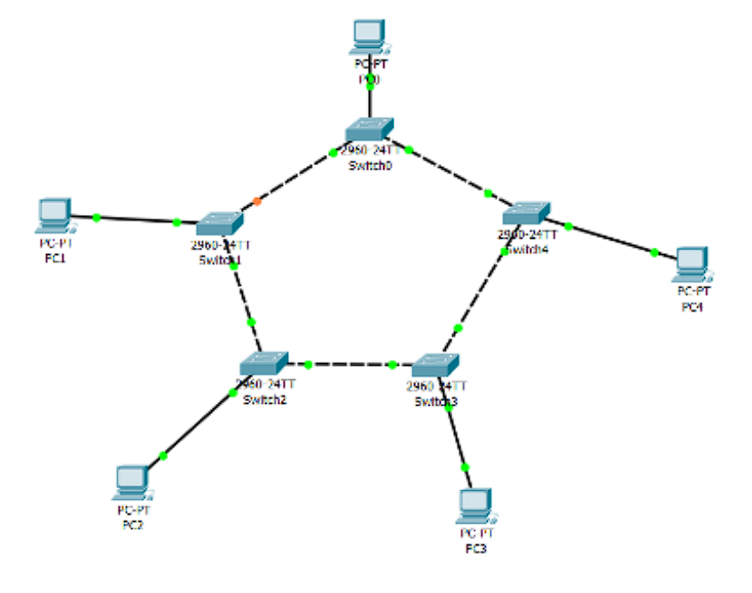

**Mesh Topology**

In the mesh topology of networking, each and every device sends its own signal to the other devices that are present in the arrangement of the network.

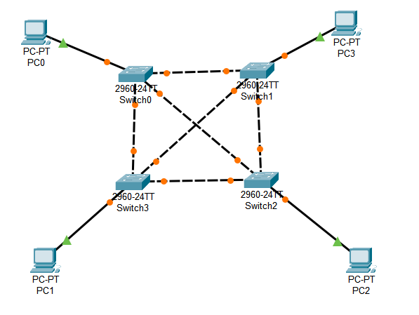

**Tree Topology**

In the tree topology of networking, the elements and devices are arranged like a tree structure and have branches of connections between the devices connected to each other.

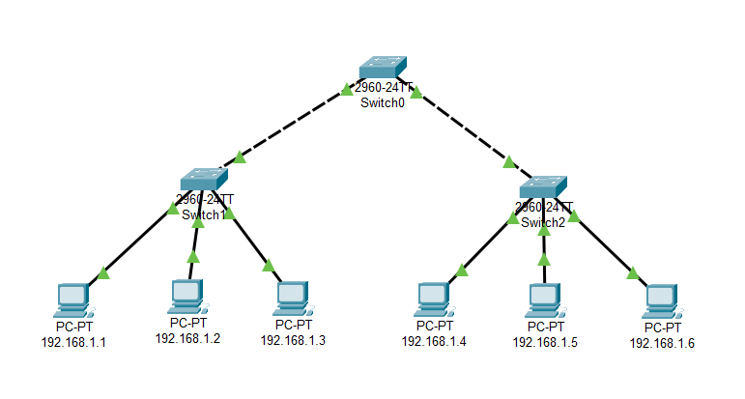

**PRACTICAL 6**

**AIM**: **Implement following topologies in packet tracer and also show the simulation mode along with proper labelling and use of colour schemes to distinguish networks**

* **Star topology**
  + **using switch**
  + **using hub**
* **Hybrid topology**

**Star Topology**

A star topology for a Local Area Network (LAN) is one in which each node is connected to a central connection point, such as a hub or switch. Whenever a node tries to connect with another node then the transmission of the message must be happening with the help of the central node. The best part of star topology is the addition and removal of the node in the network but too many nodes can cause suffering to the network.

Using Switch:

Switch is a network device which is used to enable the connection establishment and connection termination on the basis of need.

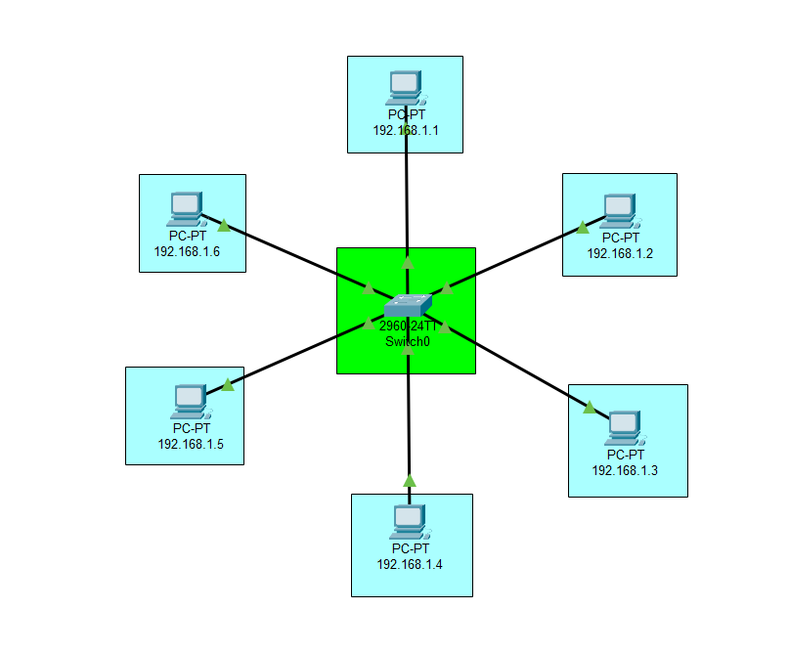

Using Hub:

Hub is a networking devices which is used to transmit the signal to each port (except

one port) to respond from which the signal was received.

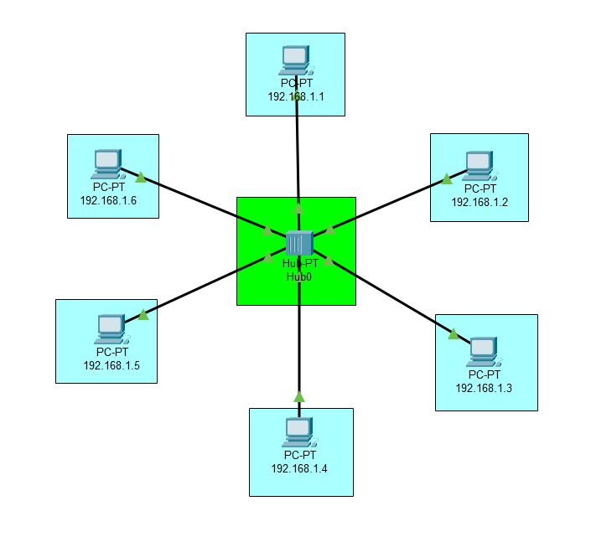

**Hybrid Topology**

The arrangement of a network that comprises nodes and connecting lines via sender and receiver is referred to as network topology. The combination of two or more topologies in a computer network is called Hybrid Topology. These combined topologies can be a combination of bus topology, mesh topology, ring topology, star topology, and tree topology.

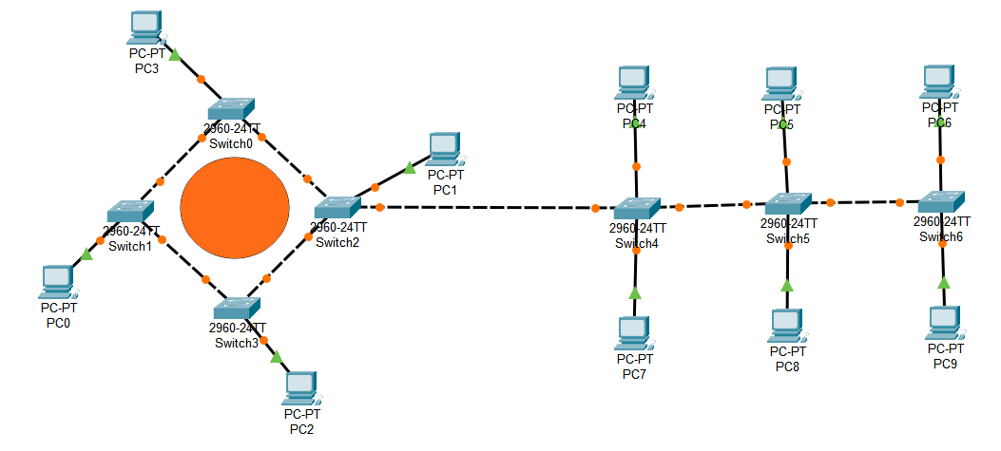

**PRACTICAL 7**

**AIM**: **Design the connectivity between 2 PC's in Cisco packet tracer when -**

* **they are on  same network (via ping and/or message sending)**
* **they are on different network via ping and/or message sending (enable Router configuration)**

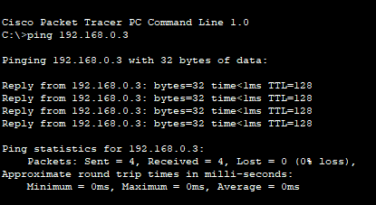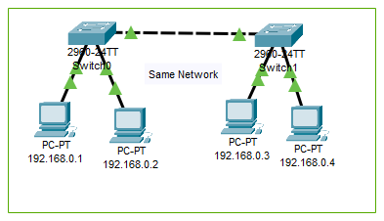

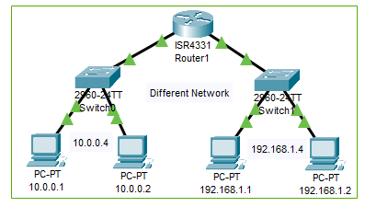

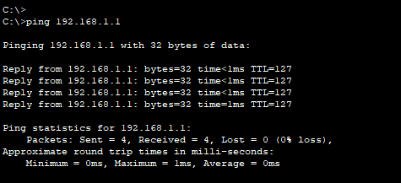

**PRACTICAL 8**

**AIM**: **Implementation of Data Link Framing method - Character Count (code in Python)**

**CODE:**

n = int(input("Enter the number of frames: "))

l = []

l2 = []

for i in range(0, n):

x = input()

l.append(x)

l2.append(len(x)+1)

sender = " "

for i in range(0, n):

sender += (str(l2[i]) + str(l[i]))

print(sender)

data = input("Enter the message: ")

i = 0

inv = 0

while (i < len(data)):

if (data[i].isnumeric() == True):

print(data[i+1:int(data[i])+i])

i += int(data[i])

**OUTPUT:**

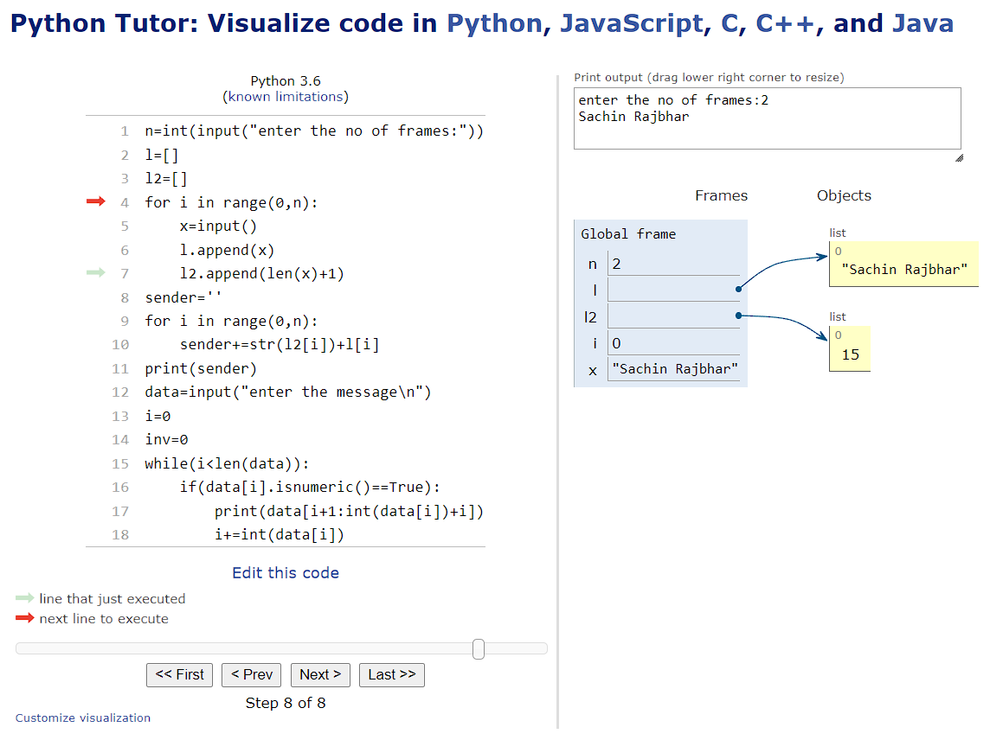

**PRACTICAL 9**

**AIM**: **Implementation of Data link framing method - Bit stuffing and Destuffing(code in Python/C).**

**Byte stuffing** is a mechanism to convert a message formed of a sequence of bytes that may contain reserved values such as frame delimiter, into another byte sequence that does not contain the reserved values.

**Bit stuffing** is the mechanism of inserting one or more non-information bits into a message to be transmitted, to break up the message sequence, for synchronization purpose.

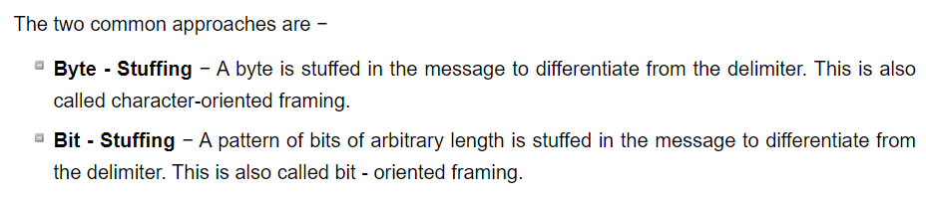

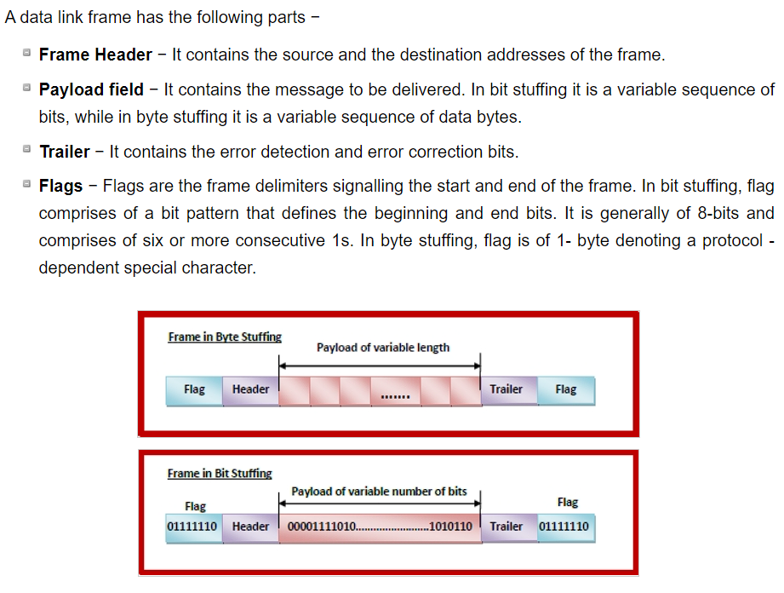

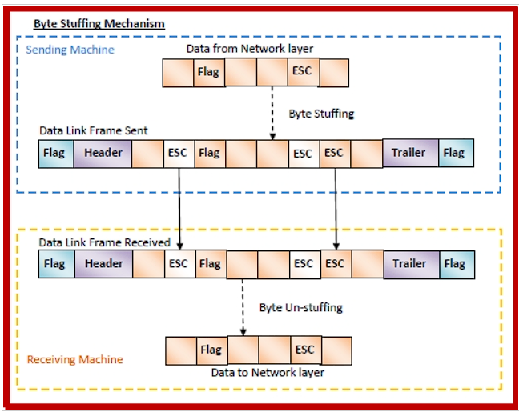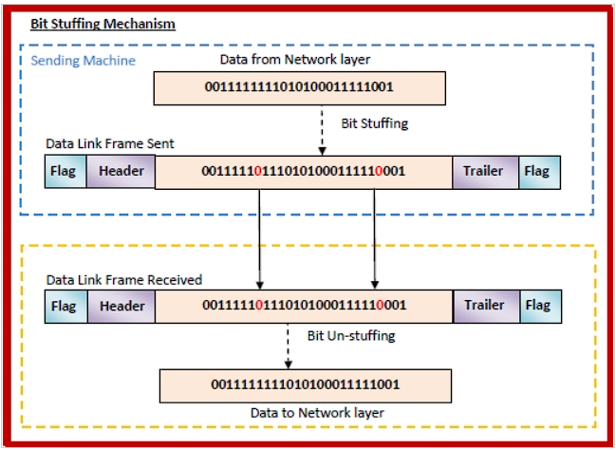

**PYTHON CODE:**

# stuffing the stuffed signal

def stuff(sig):

onec = 0 # one counter

c = 0 # index counter

one = [] # one indexes

s = list(sig)

for i in s:

c += 1

if i == '0':

onec = 0

else:

onec += 1

if onec == 5:

one.append(c)

onec = 0

k = 0 # count extra index number

for i in one:

# print(i)

s.insert(i + k, '0')

k += 1

return s

# destuffing the stuffed signal

def destuff(sig):

onec = 0 # one counter

c = 0 # index counter

one = [] # one indexes

sig = list(sig)

for i in sig:

c += 1

if i == '0':

onec = 0

else:

onec += 1

if onec == 5:

one.append(c)

onec = 0

k = 0 # count extra index number

for i in one:

# print(i)

sig.pop(i + k)

k -= 1

return sig

sig = input("Enter the signal: ")

print("Original Signal : ", sig)

stf = stuff(sig)

print("Stuffed Signal : ", end="")

print("".join([x for x in stf]))

# dstf = destuff(stf)

# print("Destuffed Signal : ", end="")

# print("".join([x for x in dstf]))

**OUTPUT:**

**PRACTICAL 10**

**AIM**: **Study of network IP Addressing and Subnetting concepts**

* IP Addresses
* An IP address is a 32-bit number. It uniquely identifies a host (computer or other device, such as a printer or router) on a TCP/IP network.
* IP addresses are normally expressed in dotted-decimal format, with four numbers separated by periods, such as 192.168.123.132. To understand how subnet masks are used to distinguish between hosts, networks, and subnetworks, examine an IP address in binary notation.
* For example, the dotted-decimal IP address 192.168.123.132 is (in binary notation) the 32-bit number 11000000101010000111101110000100 . This number may be hard to make sense of, so divide it into four parts of eight binary digits.
* These 8-bit sections are known as octets. The example IP address, then, becomes 11000000.10101000.01111011.10000100. This number only makes a little more sense, so for most uses, convert the binary address into dotted-decimal format (192.168.123.132). The decimal numbers separated by periods are the octets converted from binary to decimal notation.\
* For a TCP/IP wide area network (WAN) to work efficiently as a collection of networks, the routers that pass packets of data between networks don't know the exact location of a host for which a packet of information is destined. Routers only know what network the host is a member of and use information stored in their route table to determine how to get the packet to the destination host's network. After the packet is delivered to the destination's network, the packet is delivered to the appropriate host.
* For this process to work, an IP address has two parts. The first part of an IP address is used as a network address, the last part as a host address. If you take the example 192.168.123.132 and divide it into these two parts, you get 192.168.123. Network .132 Host or 192.168.123.0 - network address. 0.0.0.132 - host address.
* Subnet Mask
* The second item, which is required for TCP/IP to work, is the subnet mask. The subnet mask is used by the TCP/IP protocol to determine whether a host is on the local subnet or on a remote network.
* In TCP/IP, the parts of the IP address that are used as the network and host addresses aren't fixed. Unless you have more information, the network and host addresses above can't be determined. This information is supplied in another 32-bit number called a subnet mask. The subnet mask is 255.255.255.0 in this example. It isn't obvious what this number means unless you know 255 in binary notation equals 11111111. So, the subnet mask is 11111111.11111111.11111111.00000000.
* Lining up the IP address and the subnet mask together, the network, and host portions of the address can be separated:

11000000.10101000.01111011.10000100 - IP address (192.168.123.132)

11111111.11111111.11111111.00000000 - Subnet mask (255.255.255.0)

* The first 24 bits (the number of ones in the subnet mask) are identified as the network address. The last 8 bits (the number of remaining zeros in the subnet mask) are identified as the host address. It gives you the following addresses:

11000000.10101000.01111011.00000000 - Network address (192.168.123.0)

00000000.00000000.00000000.10000100 - Host address (000.000.000.132)

* So now you know, for this example using a 255.255.255.0 subnet mask, that the network ID is 192.168.123.0, and the host address is 0.0.0.132. When a packet arrives on the 192.168.123.0 subnet (from the local subnet or a remote network), and it has a destination address of 192.168.123.132, your computer will receive it from the network and process it.
* Almost all decimal subnet masks convert to binary numbers that are all ones on the left and all zeros on the right. Some other common subnet masks are:

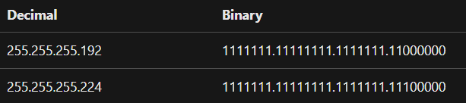

* Network Classes
* Internet addresses are allocated by the InterNIC, the organization that administers the Internet. These IP addresses are divided into classes. The most common of them are classes A, B, and C. Classes D and E exist, but aren't used by end users. Each of the address classes has a different default subnet mask. You can identify the class of an IP address by looking at its first octet. Following are the ranges of Class A, B, and C Internet addresses, each with an example address:
* Class A networks use a default subnet mask of 255.0.0.0 and have 0-127 as their first octet. The address 10.52.36.11 is a class A address. Its first octet is 10, which is between 1 and 126, inclusive.
* Class B networks use a default subnet mask of 255.255.0.0 and have 128-191 as their first octet. The address 172.16.52.63 is a class B address. Its first octet is 172, which is between 128 and 191, inclusive.
* Class C networks use a default subnet mask of 255.255.255.0 and have 192-223 as their first octet. The address 192.168.123.132 is a class C address. Its first octet is 192, which is between 192 and 223, inclusive.
* Subnetting
* Instead of requesting more address blocks for each network, you divide your network into subnets that enable you to use one block of addresses on multiple physical networks.
* In this case, you divide your network into four subnets by using a subnet mask that makes the network address larger and the possible range of host addresses smaller. In other words, you are 'borrowing' some of the bits used for the host address, and using them for the network portion of the address. The subnet mask 255.255.255.192 gives you four networks of 62 hosts each. It works because in binary notation, 255.255.255.192 is the same as 1111111.11111111.1111111.11000000. The first two digits of the last octet become network addresses, so you get the additional networks 00000000 (0), 01000000 (64), 10000000 (128) and 11000000 (192). (Some administrators will only use two of the subnetworks using 255.255.255.192 as a subnet mask.
* Using a subnet mask of 255.255.255.192, your 192.168.123.0 network then becomes the four networks 192.168.123.0, 192.168.123.64, 192.168.123.128 and 192.168.123.192. These four networks would have as valid host addresses:

192.168.123.1-62 192.168.123.65-126 192.168.123.129-190 192.168.123.193-254

* Remember, again, that binary host addresses with all ones or all zeros are invalid, so you can't use addresses with the last octet of 0, 63, 64, 127, 128, 191, 192, or 255.
* You can see how it works by looking at two host addresses, 192.168.123.71 and 192.168.123.133. If you used the default Class C subnet mask of 255.255.255.0, both addresses are on the 192.168.123.0 network. However, if you use the subnet mask of 255.255.255.192, they are on different networks; 192.168.123.71 is on the 192.168.123.64 network, 192.168.123.133 is on the 192.168.123.128 network.

**PRACTICAL 11**

**AIM**: **Study and Implementation of Firewall**

1. Open firewall and network protection.
2. Go to advance setting
3. Now go to Inbound Rules
4. Click on the Inbound Rules that you want to enable or disable.
5. Now enable or disable the rules that you want.
6. From Actions in the right corner you can add New Rules.
7. Select the Inbound Rule that you want to Disable/Enable a window will appear in the right side and you are done.

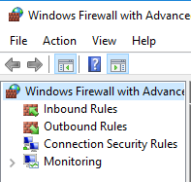

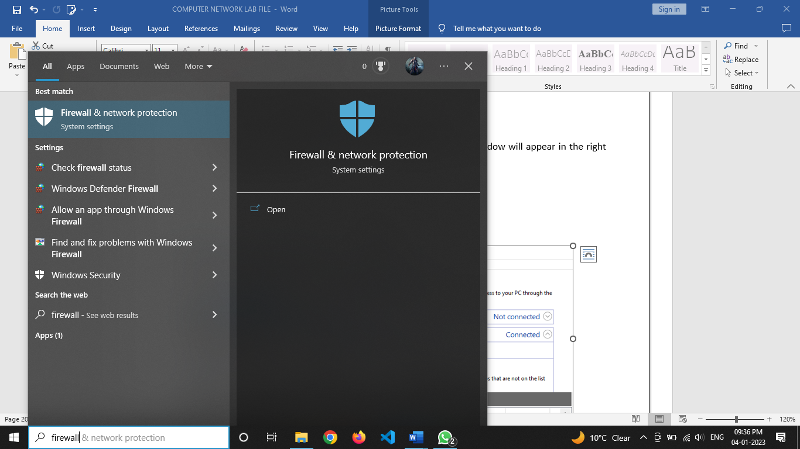

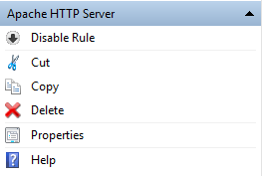

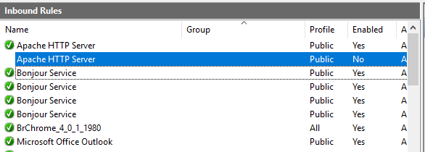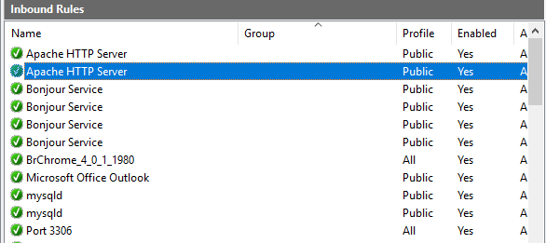

**PRACTICAL 12**

**AIM**: **To monitor network traffic using Wire Shark**

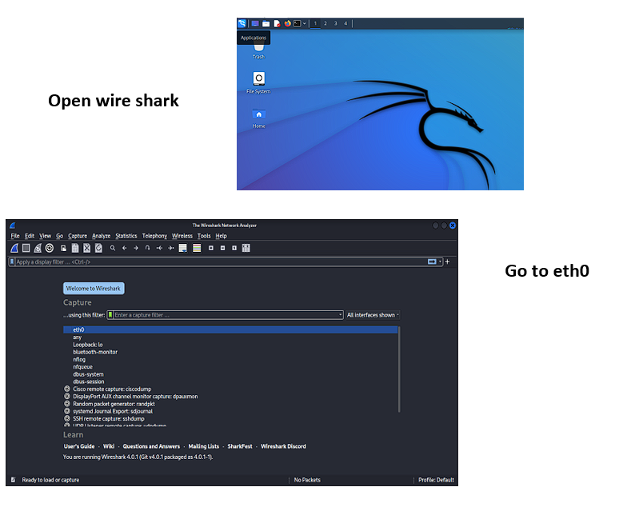

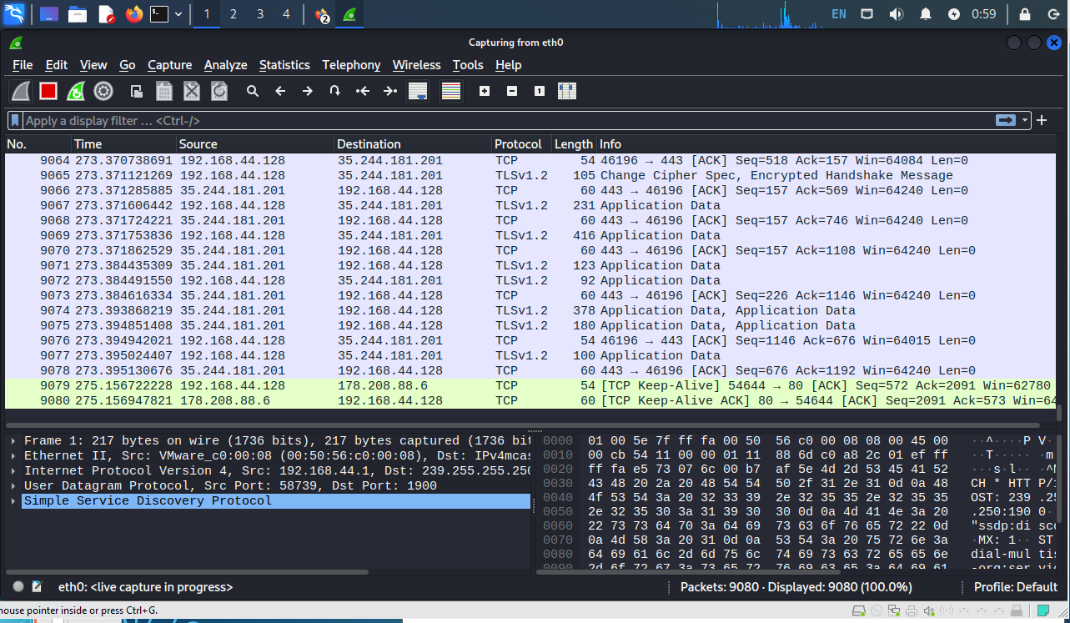**You can see your**

**system Network traffic**

**Now we check through by a website we track our username and password through http website**

**We fill username and password**

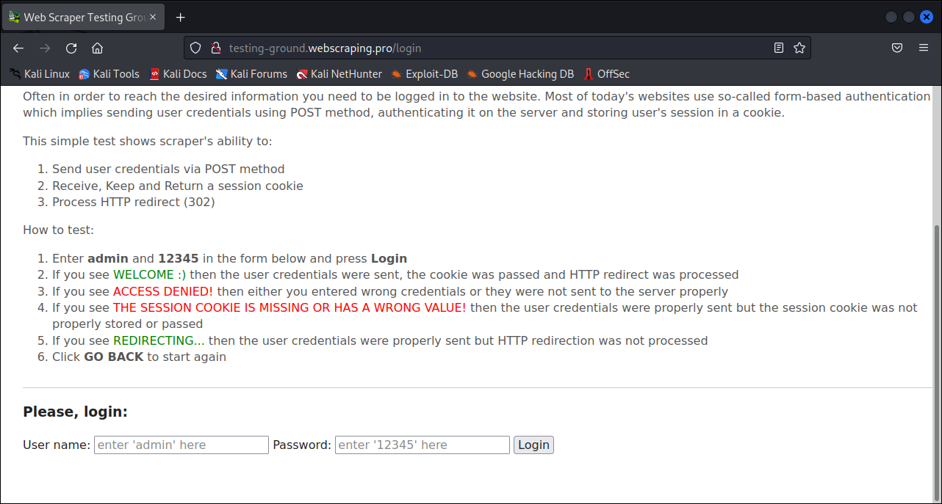

**Now write http and its result**

**Now write http and its result**

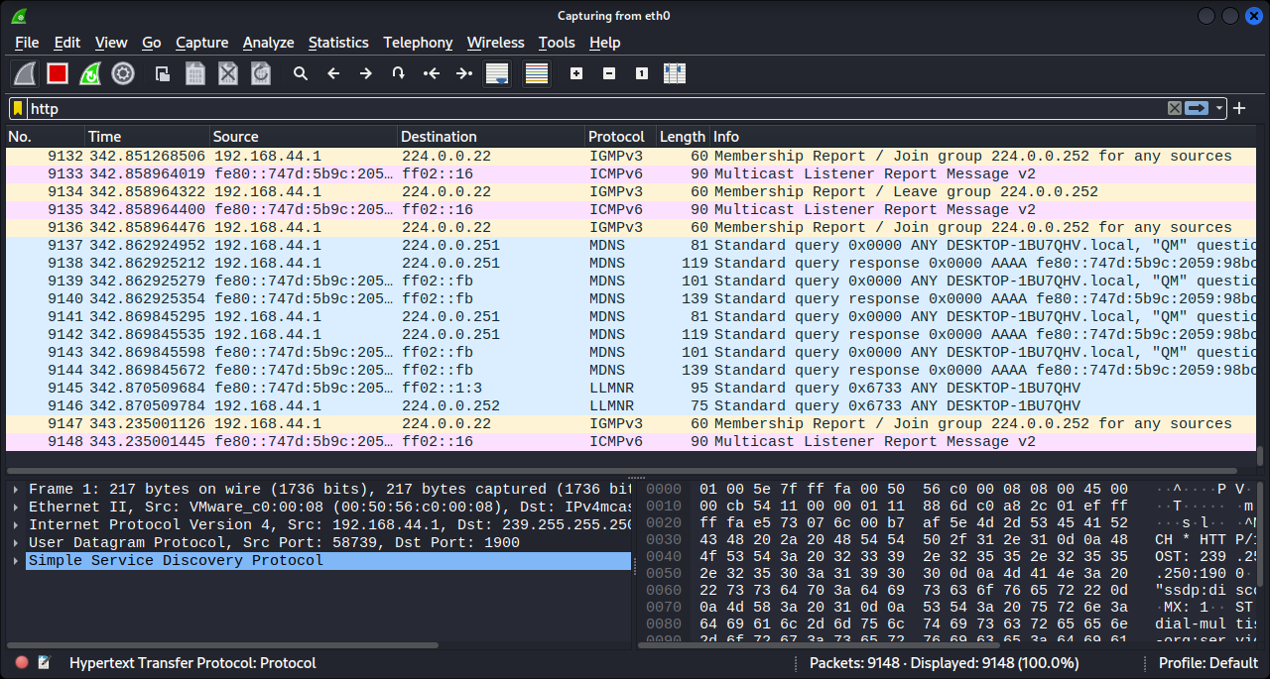

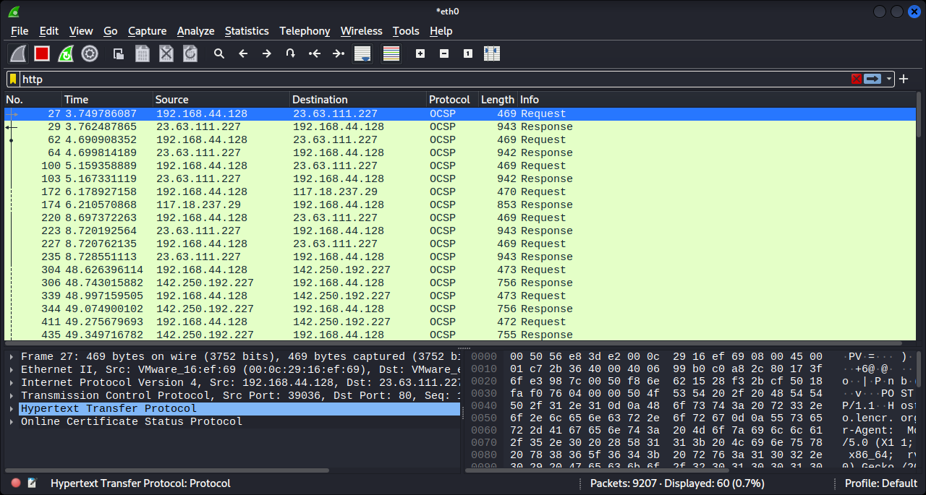

**First way to see username and password**

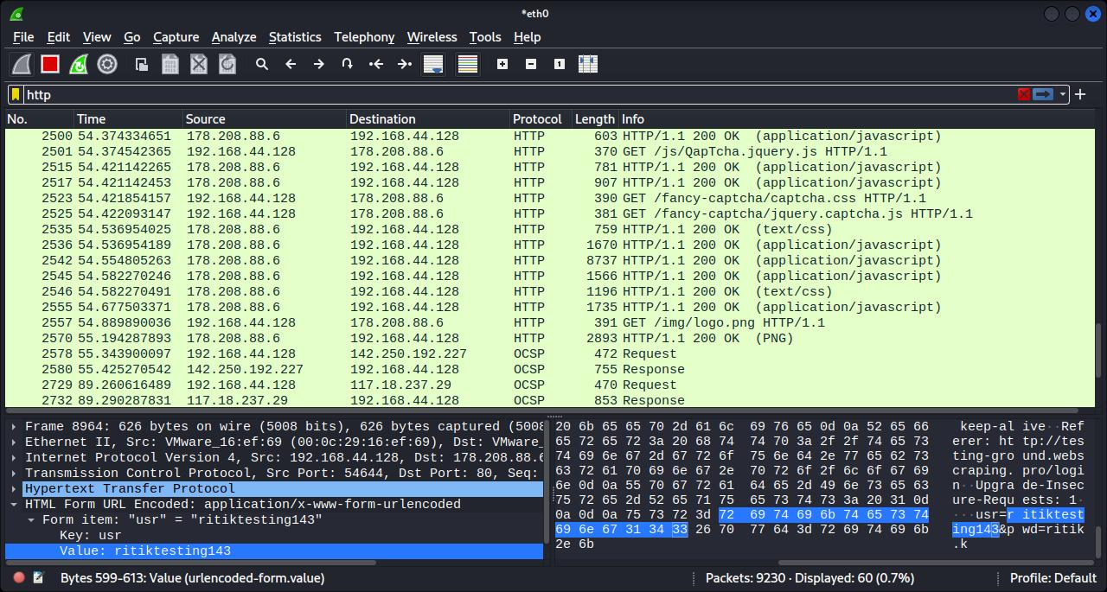

**Second way to see username and password**

**Step 1 right click on post/login visited page**

**Second way to see username and password**

**Step 1: right click on post/login visited page**

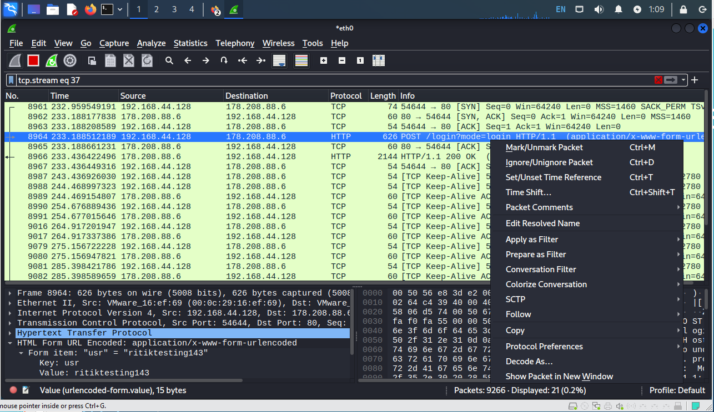

**Step 2 click on follow then click on http stream and write pwd at find checkbox**

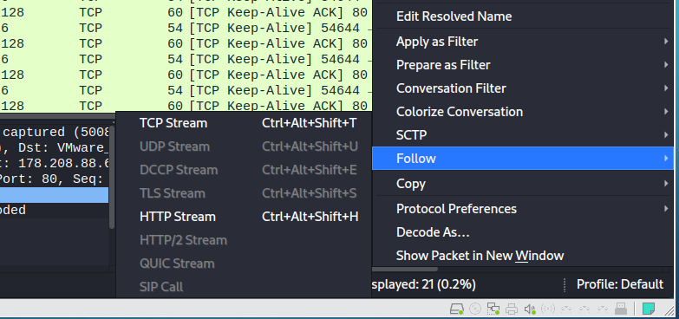

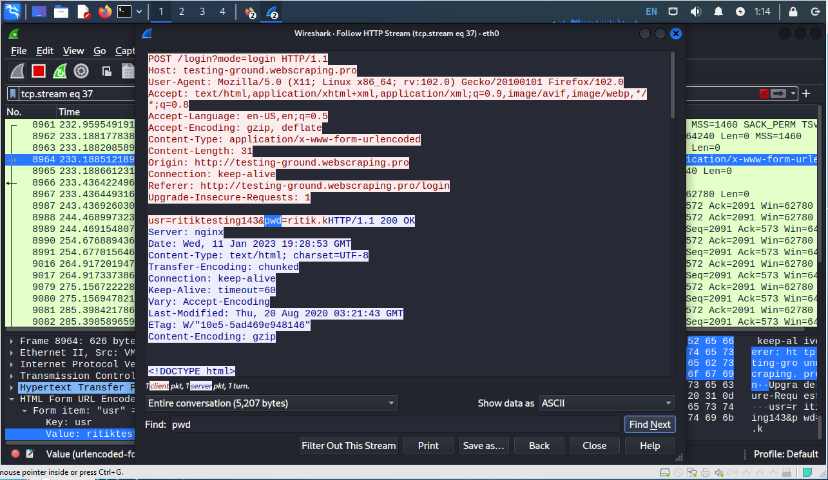

**Step 3 you can track your username and password**

**Step 3 you can track your username and password**



**PRACTICAL 13**

**AIM**: Implement error detection method-Even and Odd Parity in Python.

**CODE:**

def Fun_Parity( num ):

    parity = 0

    while num:

        parity = ~parity

        num = num & (num - 1)

    return parity

num = int(input("Enter a number: "))

print ("The Parity of ", num," is: ",

    ( "odd" if Fun_Parity(num) else "even"))

**DIAGRAM:**

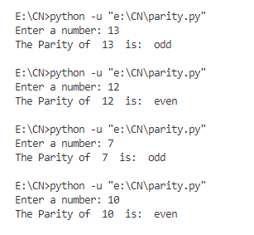

**PRACTICAL 14**

**AIM**: Static & Dynamic Routing

Static Routing:

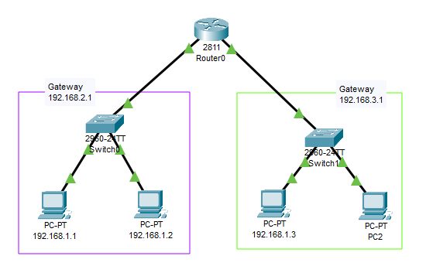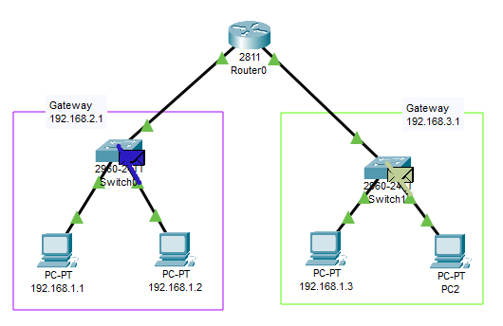

Dynamic Routing:

Dynamic Routing:

